**36.** ALV_LIST_DISPLAY Output

Below is the Selection screen .Give a suitable CARRID and Execute.

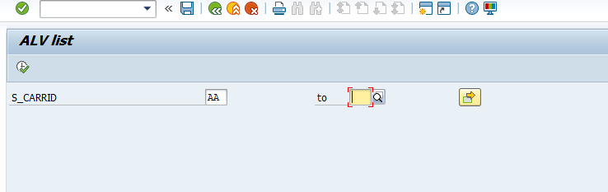

The expected output is as follows

